THE HEARTIES
NEWSLETTER
Charity No. 1089481 Nov/Dec 2015 No. 227
The November Meeting
Stephen Kelsey, a psychologist, was our guest and one of the best we have had for some time. His fluent presentation, which included a theory of the world’s future, was interesting and provided food for thought. He was so good that those present were unusually quiet and he was not interrupted. He also refused to receive any payment.

The Festive Meal
A great turnout enjoyed a relaxing evening at Table Table. The food was okay and everyone appeared to enjoy themselves. The waitress had a pleasant attitude and was super efficient. Pat Palmer and Eff Orwell worked very hard in arranging the evening and managing to get the meals at cut price and I am sure that those present will join Jackie and me in thanking them for a lovely time.

New Year Hampers
Many thanks to those of you who have already donated items for the hampers to be raffled at the New Year party. The hampers are put together on the evening so there is one last opportunity for you to bring in any items that you can spare. Thank you in anticipation.

Donations
Many thanks for postage stamps received from Elsie Harrison, Pat Dorling, Margaret and Eddy Sheehy and Mr and Mrs Holden. These are always welcome. Thanks also to Eff Orwell for supplying paper on which newsletters sent by post are printed. Although about 100 newsletters are sent by email more than that number are still sent by post.

February 2016
Last February we had a bring and buy auction which was well attended and a lot of fun. It also raised £250. We are hoping to have another fun auction at the February meeting the proceeds of which will be donated to HH for the benefit of its members. The items to be auctioned will be donated by you so any items in good condition or new such as unwanted presents that you no longer want should be brought along to be auctioned off. More news about this at our next meeting and in the next newsletter.

The Great War
Please find attached/enclosed a poster offering a half price year’s subscription to this wonderful 76 page magazine. I have been a member since issue one about 15 years ago. It is published every quarter (four yearly). The publishers are hoping to find new customers otherwise they will be forced to issue online only. This glossy publication carries no advertisements and I would consider it a personal favour if you could spare £15. You would not be disappointed. Thank you.

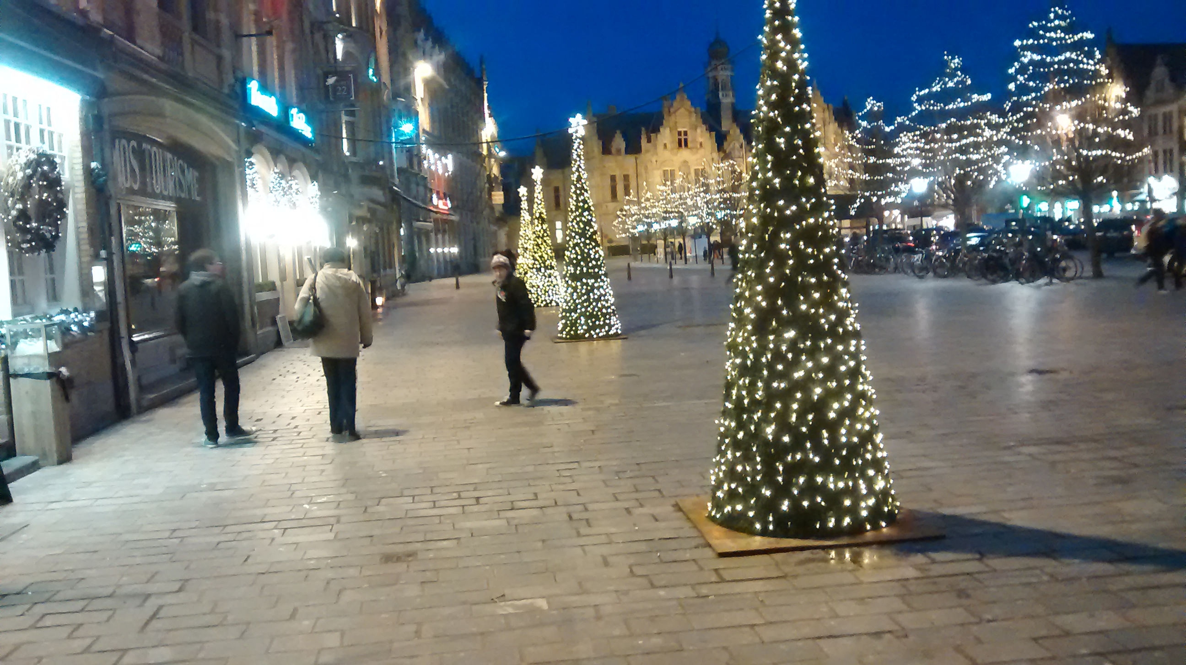Jackie and two grandsons in Ypres 12.11.2015

On behalf of the committee best wishes to everyone for Xmas and the New Year

